Evansville Education Foundation Grants for 2019-2020 School Year

Thanks to the generosity of our community, the Evansville Education Foundation (EEF) has granted ECSD teachers thousands of dollars to explore innovative programs outside of the standard curriculum again this year. This year, grants ranged from sessions with an Overture Center musician to escape room-style problem solving kits. EEF grants are selected based on their academic focus and ability to impact large numbers of students. As usual, the energetic and creative ECSD staff rose to the challenge: grants cover all grade levels and learning styles to help every student do their best.

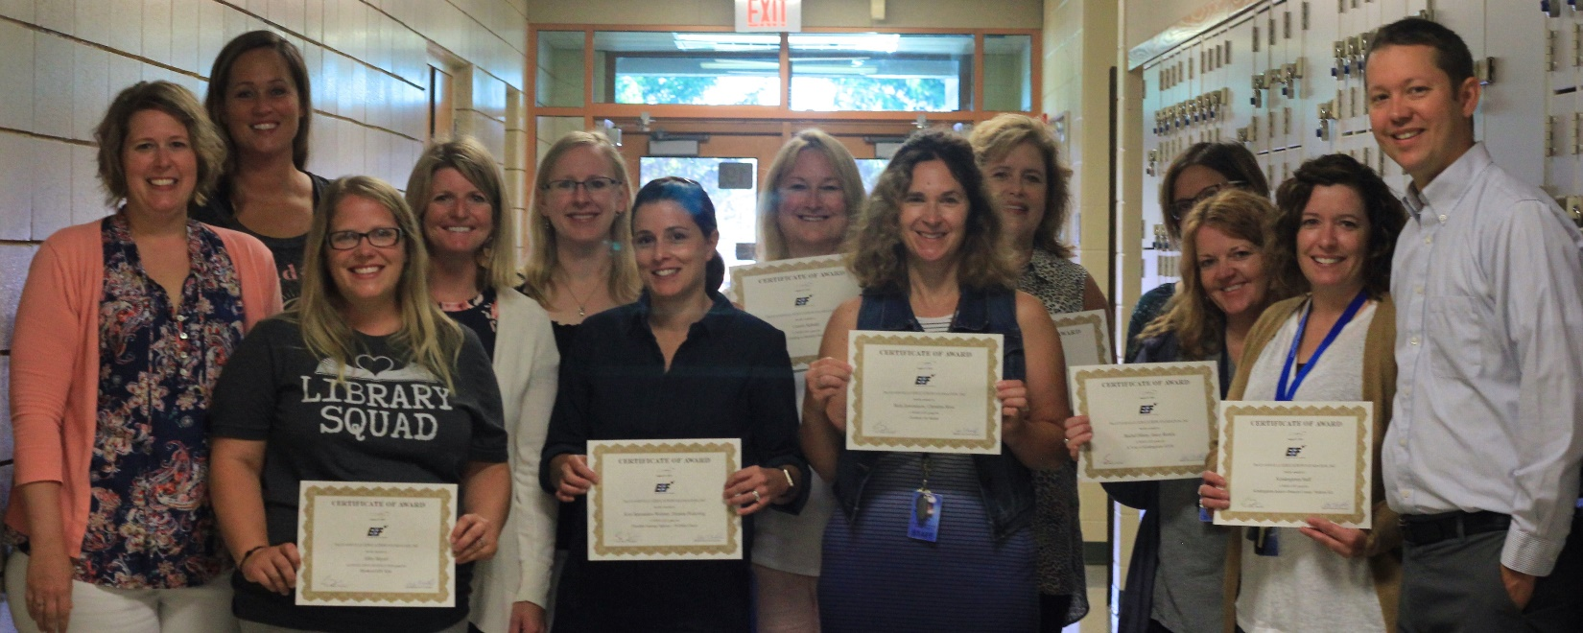

Congratulations to this year’s winners! From left to right:
- Meghann Proper: 8th grade Imagination Vacation (Overture Center musician sessions)
- Kate Burton: 3rd grade Flexible seating — Bucket Seats
- Abby Beyerl: K-12 Breakout EDU (escape room-style puzzles)
- Rachel Wenzel: K-5 Author Visit (Jacqueline Briggs Martin)
- Deanna Pickering: 4th grade Flexible seating — Wobble Chairs
- Kim Sperandeo-Wehner: 4th grade Flexible seating — Wobble Chairs
- Connie Schultz: 4th grade STEM — Creating a Modular Modern Home kits
- Christina Ross: Ozobots for 2nd grade STEAM education
- Kelley Gransee: K-5 Author Visit (Jacqueline Briggs Martin)
- Beth Jeremiason: Ozobots for 2nd grade STEAM education
- Rachel Marty: A Year of Kindergarten STEM (interdisciplinary supplies)
- Jenny Runkle: A Year of Kindergarten STEM (interdisciplinary supplies)
- Also pictured: EEF president Cory Neeley
The Kindergarten staff also received a grant for a Kindergarten Indoor Obstacle Course/Stations Kit.
These grants are supplied entirely by donations from our community. Follow the EEF on Facebook or visit their website (www.evansvilleeducationfoundation.org) to donate and for updates on these grants throughout the year.
The EEF is a non-profit organization whose mission is to support learning in the Evansville Community School District.

